Java Streams
What is Stream?
Java Streams represent a pipeline of operations that process data from a source (List, Set, Map, Arrays).
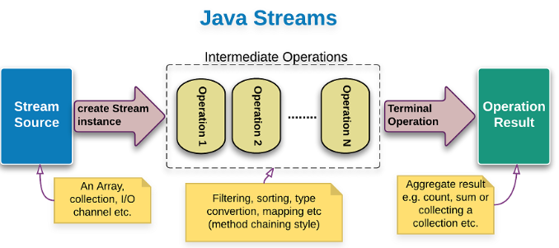
- Do not store data
- Do not modify original collection
- Are lazily evaluated
- Can be consumed only once
- Support parallel processing
Stream Pipeline Structure
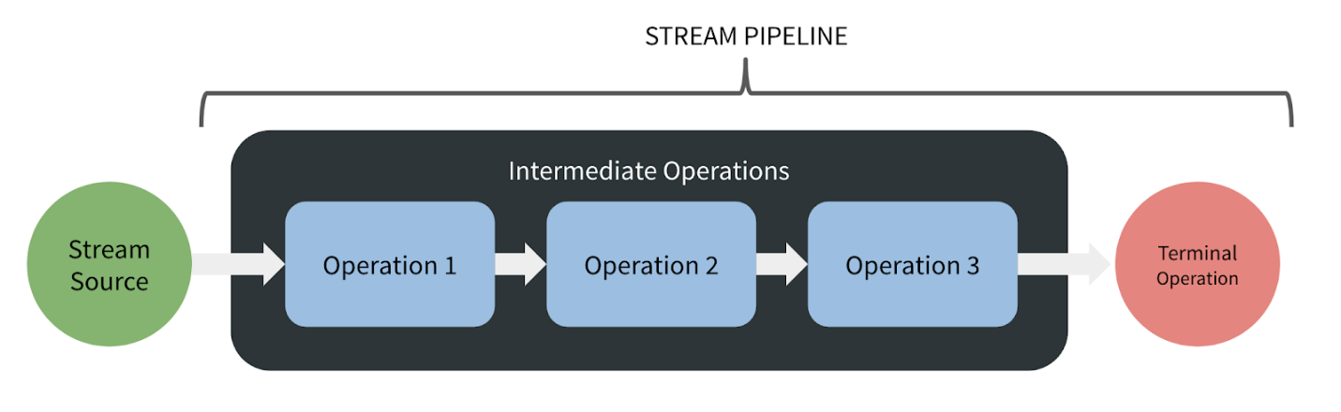

Types of Operations
Intermediate Operations (Lazy)
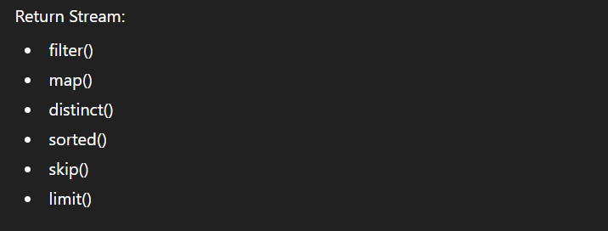
Terminal Operations (Trigger execution)
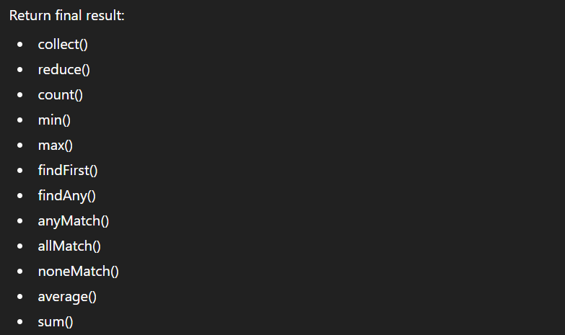
Why do we need Streams?
Before Java 8:
- External iteration (for-loops)
- More boilerplate
- Hard to parallelize
- Imperative style
With Streams:
- Declarative programming
- Clean transformation pipeline
- Functional style
- Built-in aggregation and grouping
- Easier parallel execution
Can we consume Stream only once?
Once terminal operation executes:
- Stream is closed
- Cannot reuse it
- Need to create new stream
Ex:
That is why even though this line creating 3 streams will not consume much of the data coz once the stream is consumed that’s all that is deleted.
Even though 3 operations exist,
Actual execution happens only once during terminal operation.

STREAM CREATION METHODS
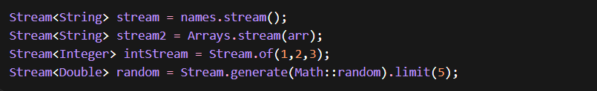

STREAMS ON PRIMITIVE & STRING COLLECTIONS
FILTER (Intermediate Operation)
Even Numbers & Odd Numbers Filter
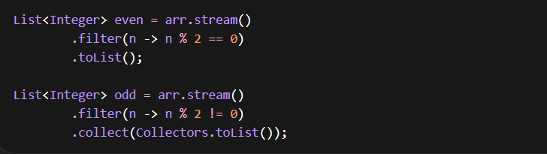
Square of Even Numbers > 5 Filter + Map
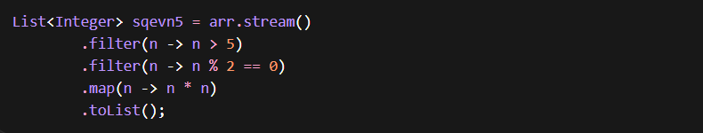
REDUCE (Terminal Operation)
Summing All Numbers
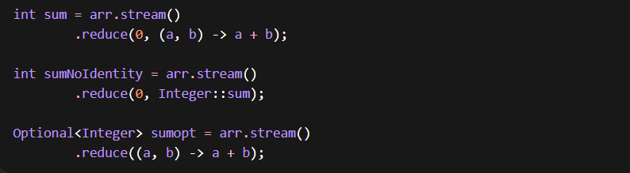
Using mapToInt()
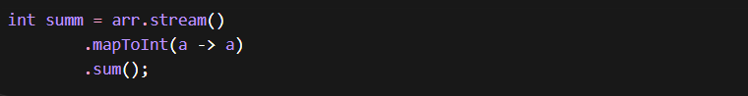
MAX / MIN
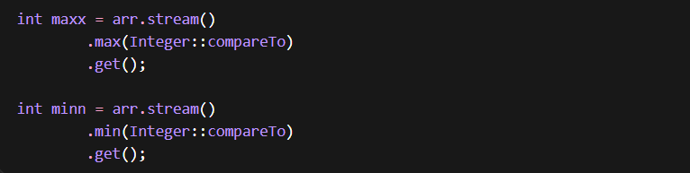
Safer version:
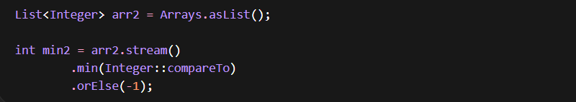
Using reduce for max/min
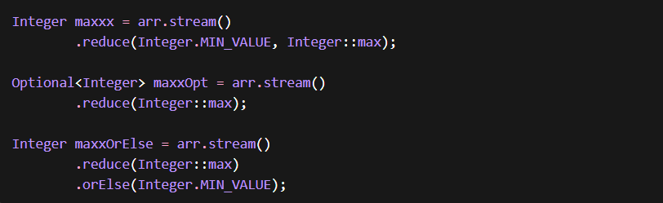
distinct()
Removes duplicate elements.
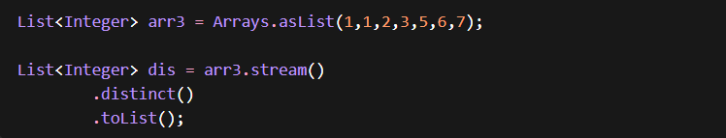

sorted()
Ascending
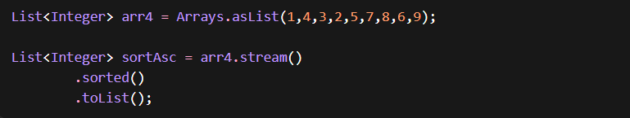
Descending
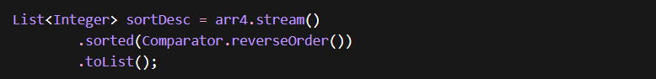
Combined Operations
Sum of even numbers
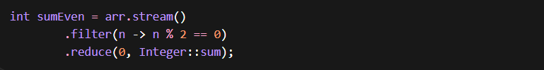
Sum of odd numbers
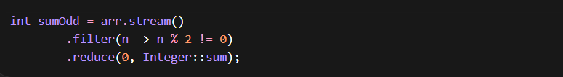
Sum of Squares of Even Numbers
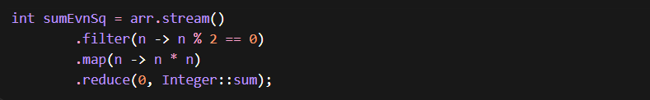

Safer Optional version:
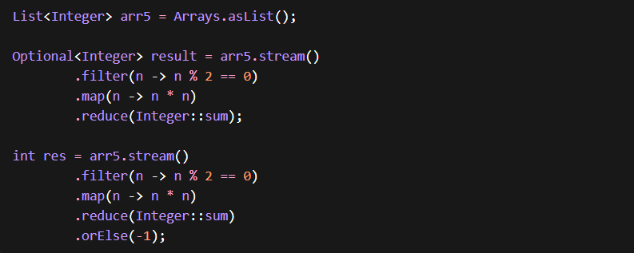
Product Using reduce()
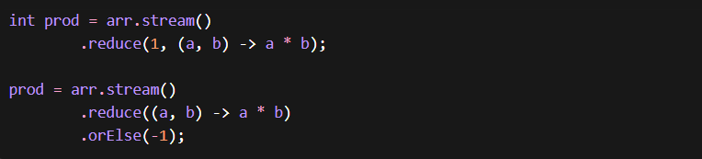
findFirst()
First Element greater than 7, greater than 1000
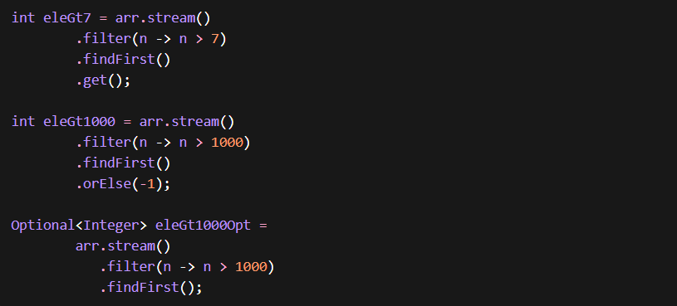

anyMatch / allMatch / noneMatch
Any element (>10), All are even, none of them are negative
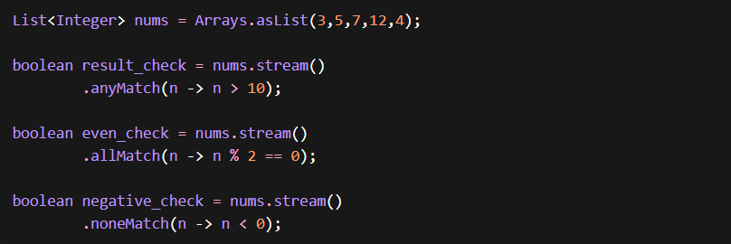
count()
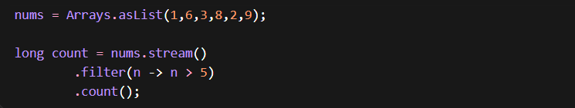
Convert List to Map String and it’s Length
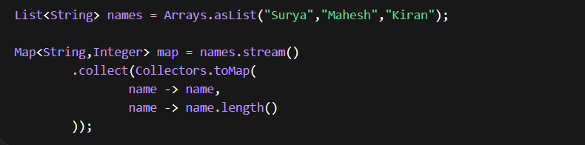
Advanced Reduce Practice
Product
Sum of Squares
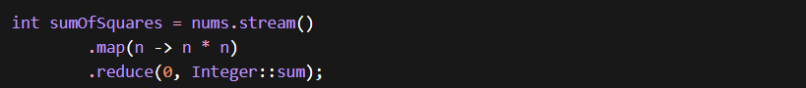
Longest String
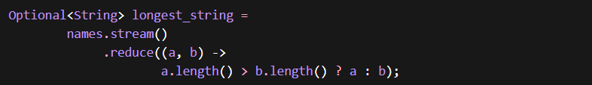
Advanced Sorting & Finding
Least
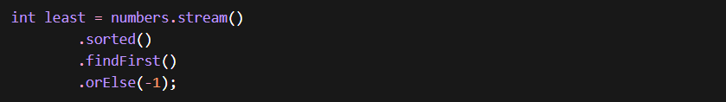
Second Highest
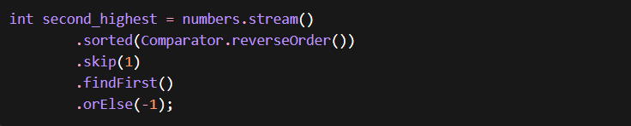
Distinct + Count + Sort
Distinct Numbers list & Count of Distinct Numbers
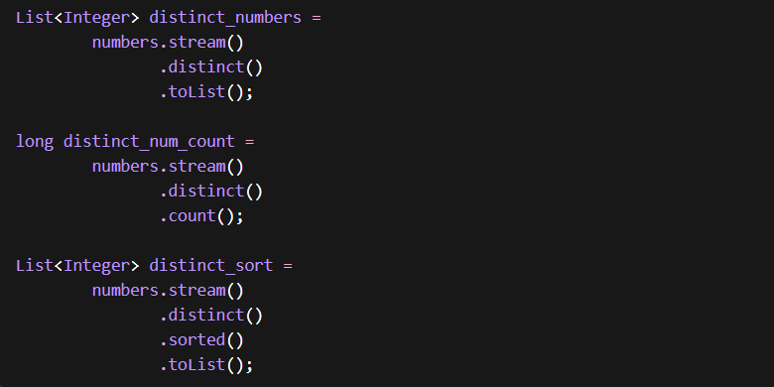

Sort all distinct elements in list

String Filtering
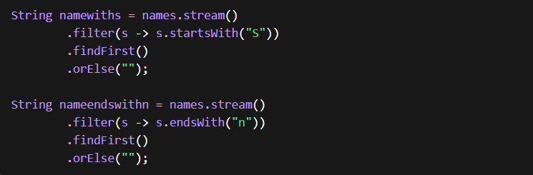
PART 2 – ClassStreams (Employee Example)
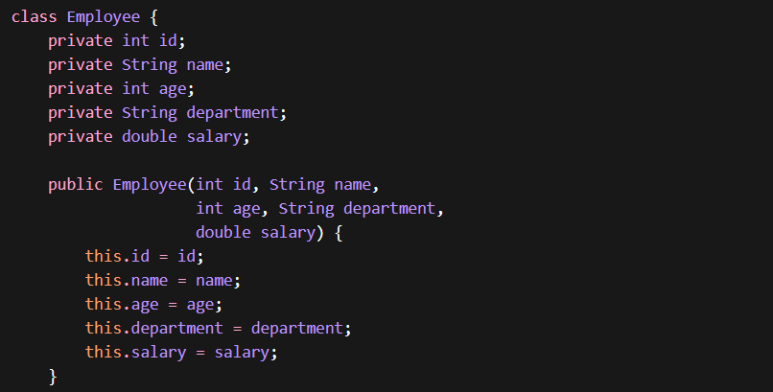
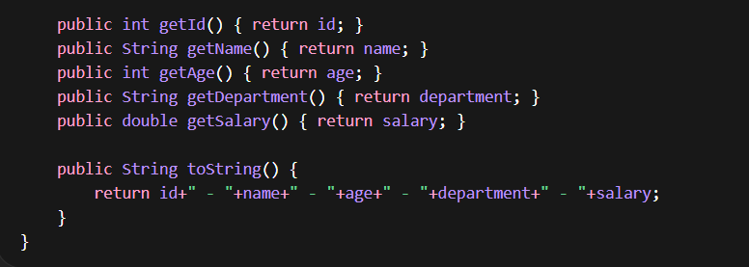
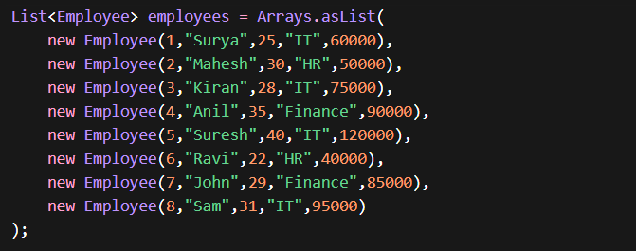
Filtering
List of Employees whose Salary > 7000
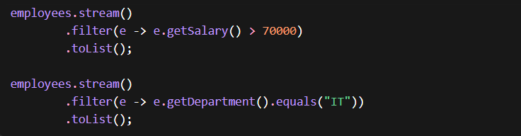
List of all IT Employees

⚠ Always use .equals() not == for Strings.

Map
List of all employee names
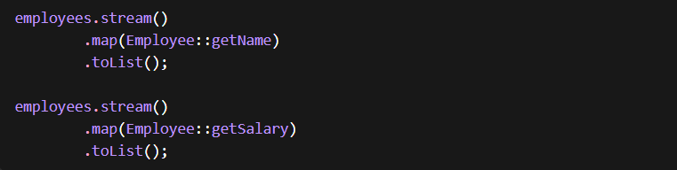
List of all employee salaries

Sum of Salaries
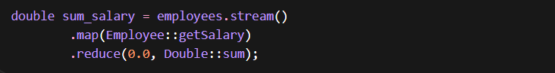
Max / Min
Employee with Highest salary
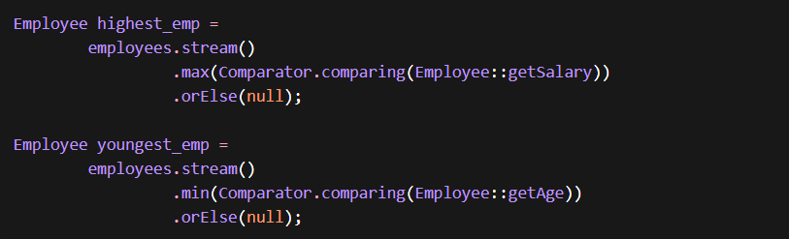
Employee with Least Age – Youngest Employee


Sorting
Sort Employees – by Salary ascending order
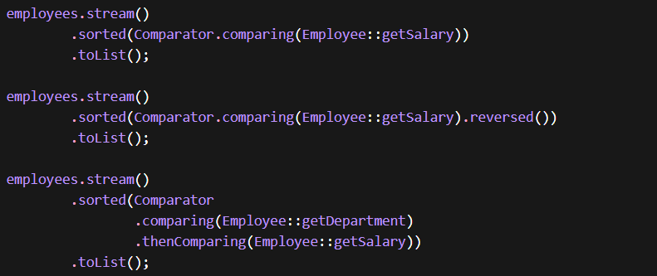
Sort Employees – by Salary descending order

Sort Employees –sort by dept then sort by Salary ascending order

findFirst / skip
Find employee with Second highest salary
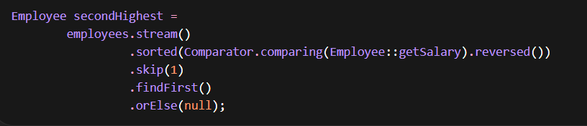
Match Operations
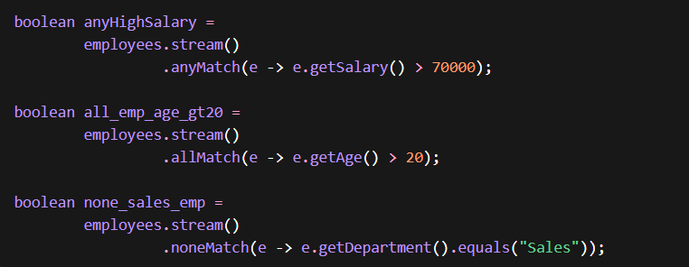

Average Salary of Employees
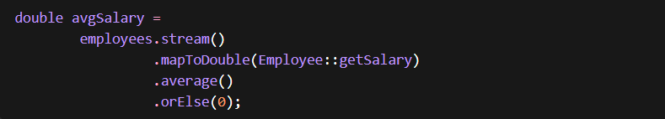
Grouping – Group by Dept & Count Number of Employees in each department
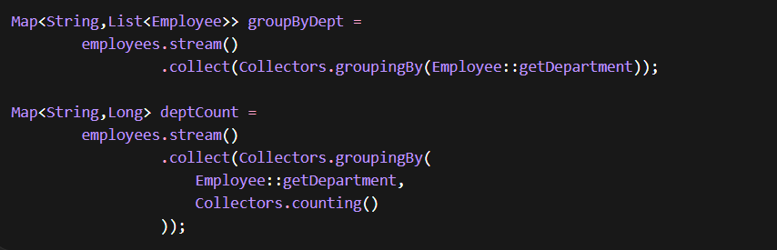

INTERVIEW QUESTIONS – LEVEL 1 (Super Easy)
List<Integer>array = Arrays.asList(1,1,1,2,3,4,5,6,7,8,9,10,100,1000);
1. Even Numbers – Filter
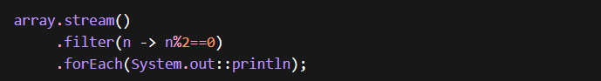
Internal Working:
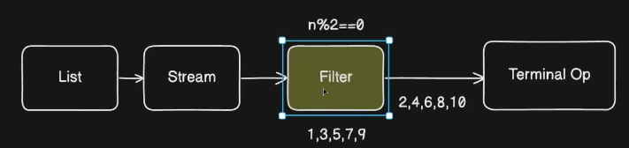
2.Convert Numbers into List of Their Squares
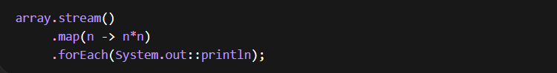
Internal working:
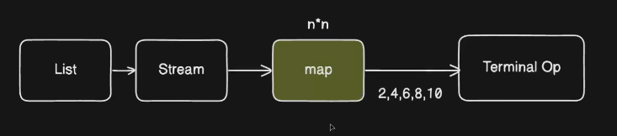
3. Square Even Numbers from List
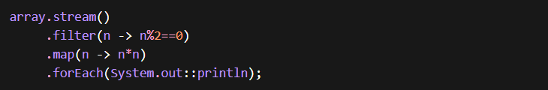
Internal Working:
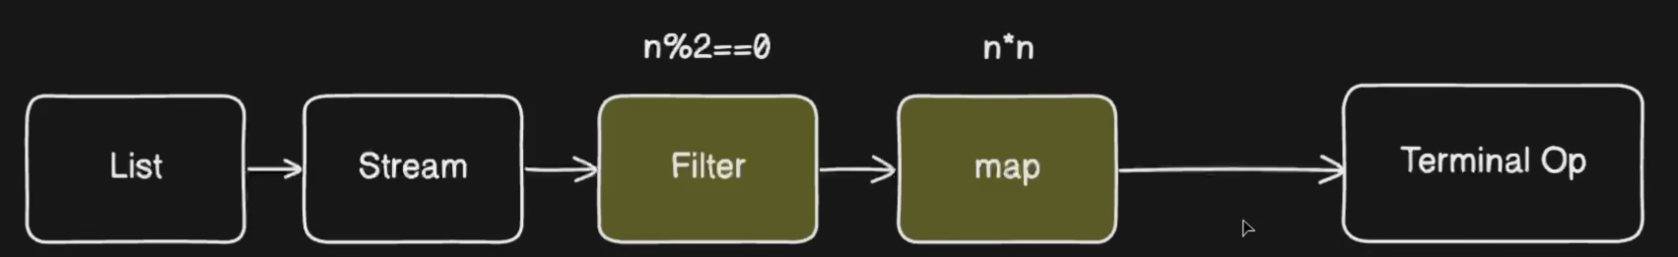
4. Find First Number Greater Than 10
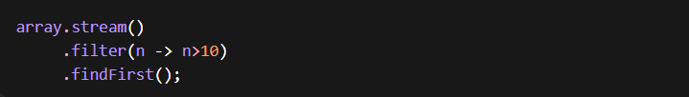
5.Count numbers are greater than 5
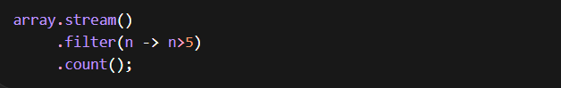
6.Find the sum/product of all numbers in list
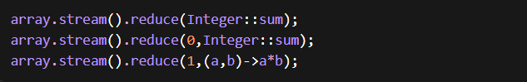
Internal working:
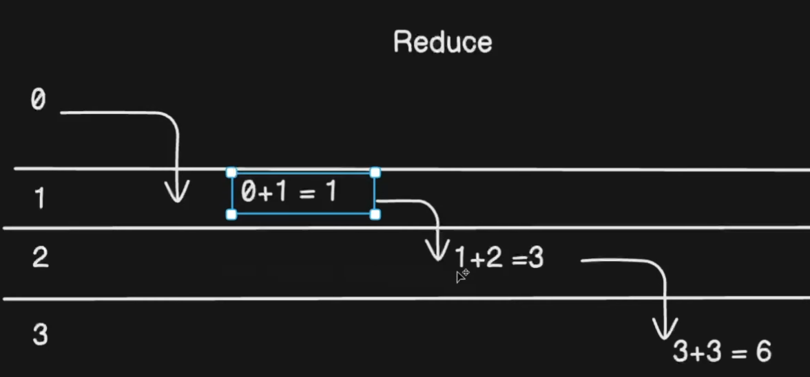
7.Find sum of Even numbers only
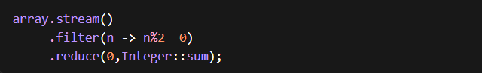
Flow
8.find maximum number in the list
9.Find sum squares even numbers in a list
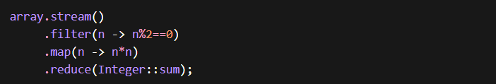
Internal Working:
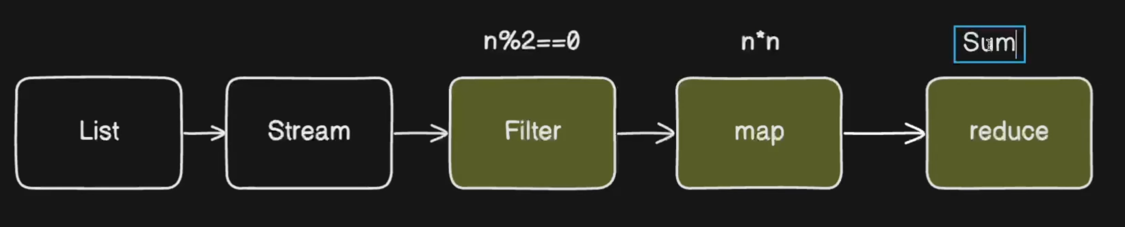
Find First Non Empty String in the list
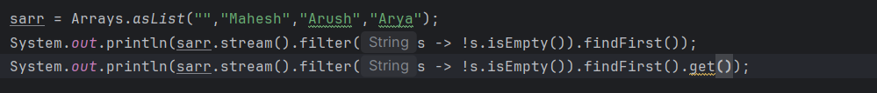
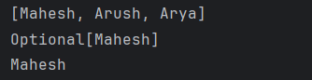
Interview Questions – Level 2 Easy
10.Find all distinct elements from a list Remove duplicates
Flow:
11.Find Average of numbers in a list
  - Stream to be Converted into IntStream
Internal working:
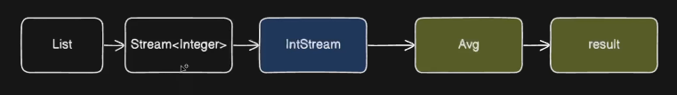
12.Sort a list of integers in Asc and Desc order
Flow:
List<String> sarr = Arrays.asList("Mahesh","Arush","Arya"))
13.Count Number of Strings Starts with a specific letter like 'A'
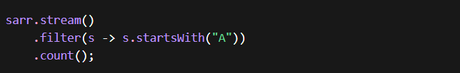
14. Join all strings in a list into a single comma seperated string
15.Join all strings in a list into a single comma seperated string,with prefix and suffix
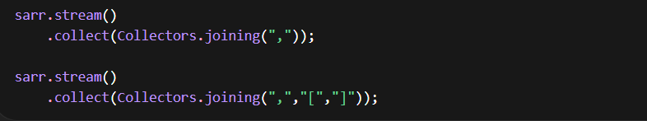
16.Check if all the elements are positive numbers allMatch()
All match Internal working:
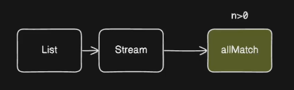
17.Check if Any number is Divisible by 3 anyMatch()
18.Flatten the list of List
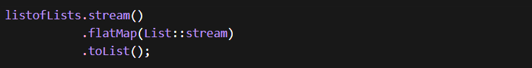
Flow:
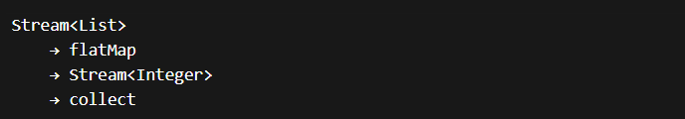
Interview Questions – Level 3 Intermediate

19. Sort Employees By Salary
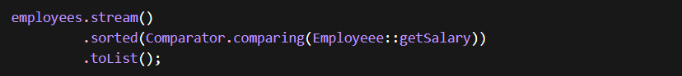
20. Calculate the average age of list of Employees Objects using Java Streams
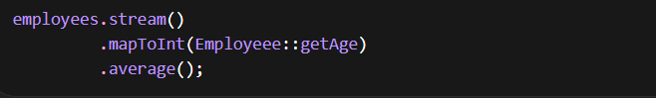
Internal Working:
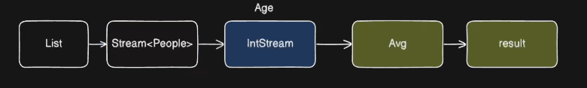
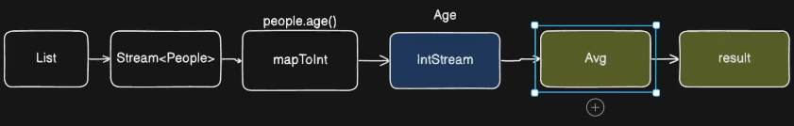

21. Partition numbers into Even and Odd
Internal Working:
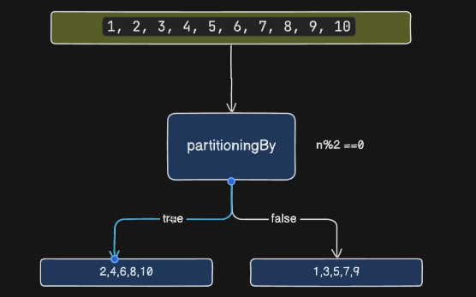
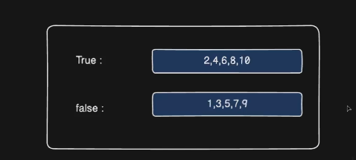

22. Group a list of words by their length using streams
Internal working:
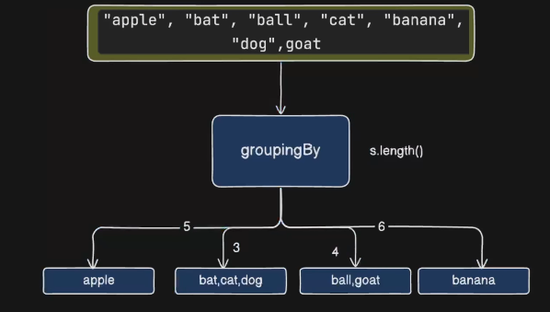

23. Count Occurrences of Each Element in a list
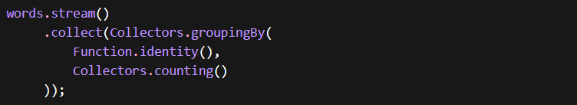
Internal Working:
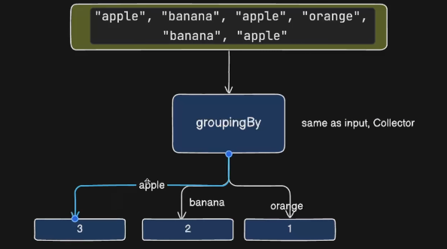

25. Group Employees by Department
Internal Working:
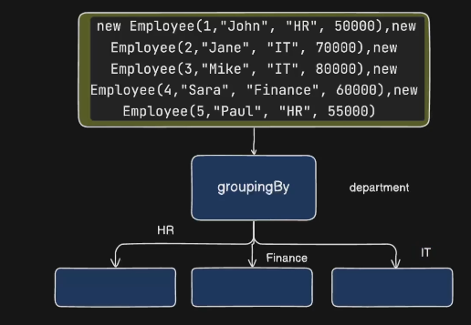
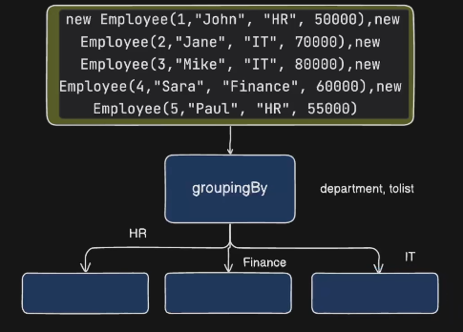

26.Group employees by department and calculate average salary
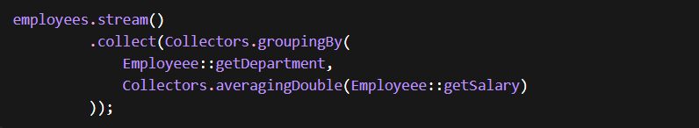
27.Highest Paid Employee in each department
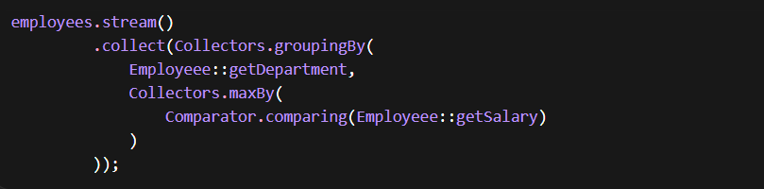
Internal Working:
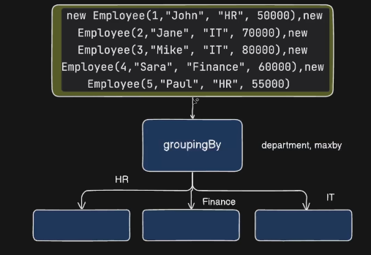

28.Find Department wise Employee Count
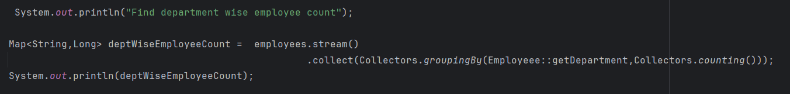
29.Find all departments with more than 2 Employees
30.Find all departments with more than 2 Employees Using Single Stream
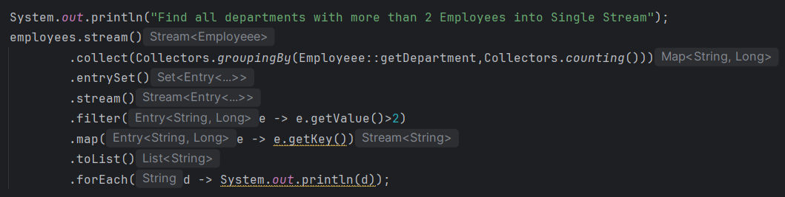
31.Find Department wise Average Salary
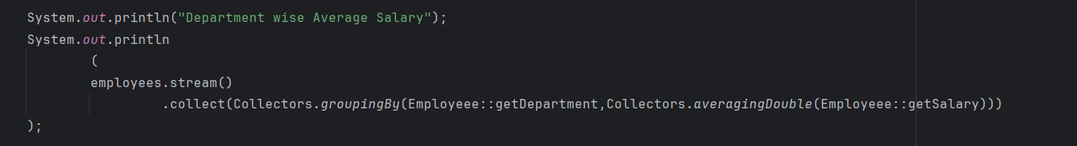
32.Find Department with Highest Average Salary
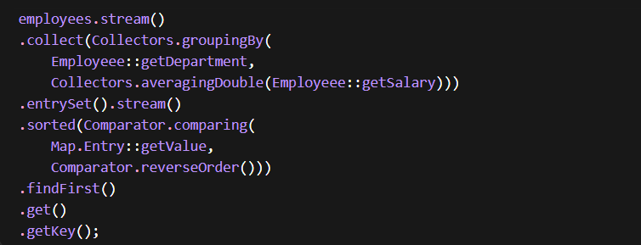
Flow:
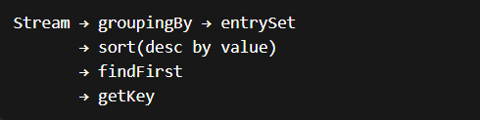
33.Find Department with Second Highest Average Salary
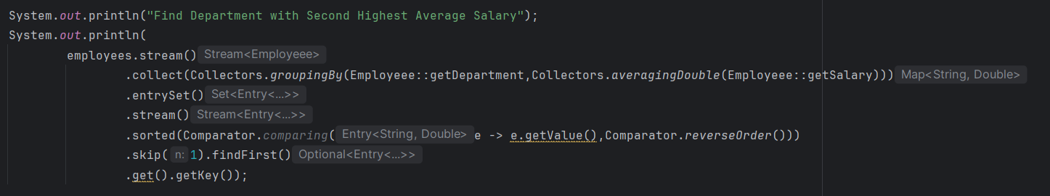
34.Find Employee with Second Highest Salary
35.Find Frequency of each character in String
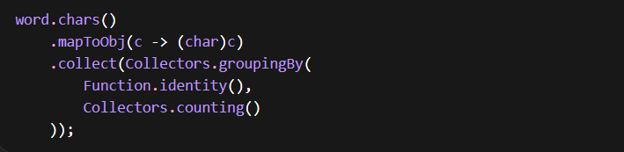
36.Find Most Frequent character in String
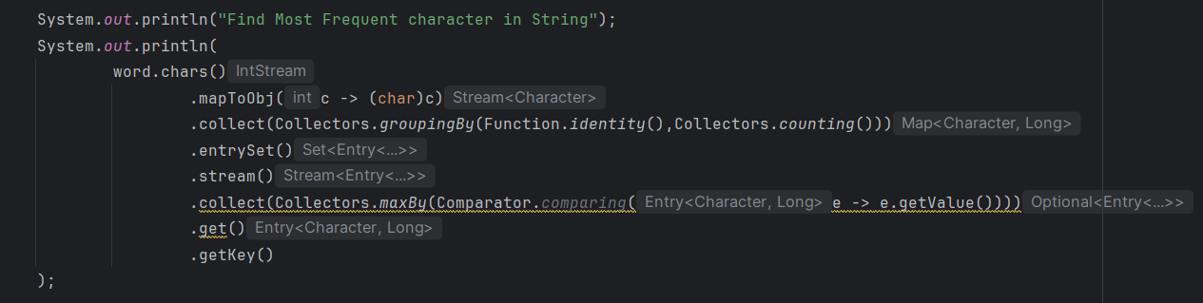
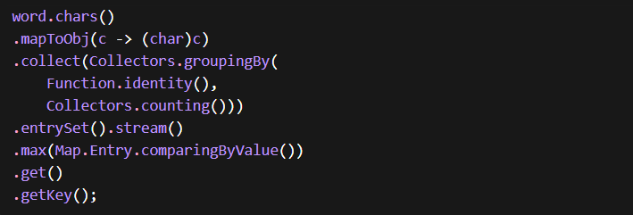
37.Find First Non Repeating Character
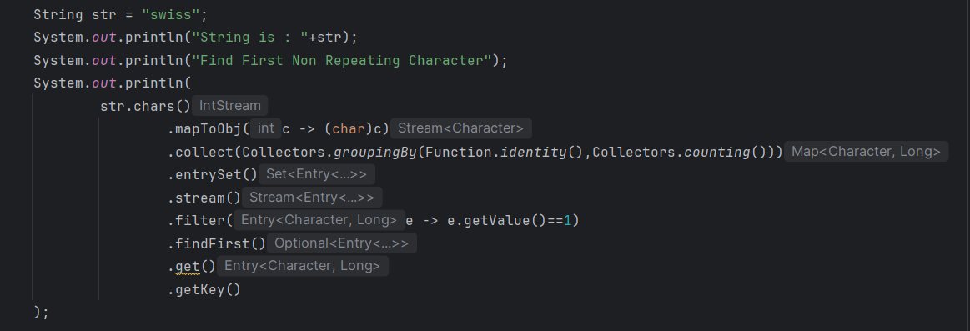
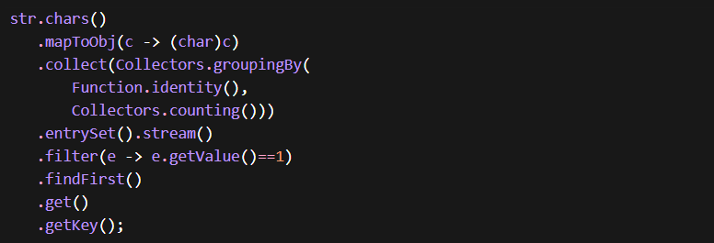

Interview Questions – Level 4 Hard
38.Frequency of Employee Names with First Letter
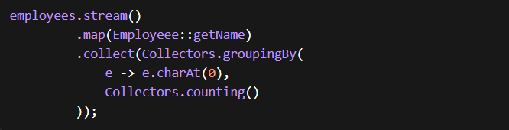
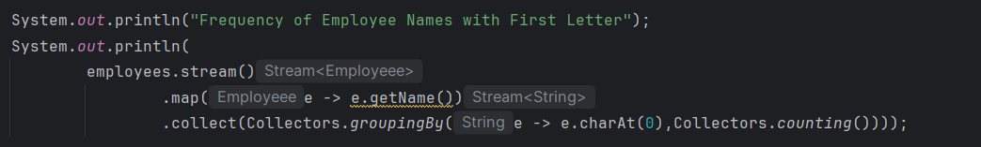
39.Find the most common first letter among all employee names
